SS8CG2 (LEGISLATIVE) – SS8CG3 (EXECUTIVE) – SS8CG5 (LOCAL GOVERNMENT) STUDY SHEET

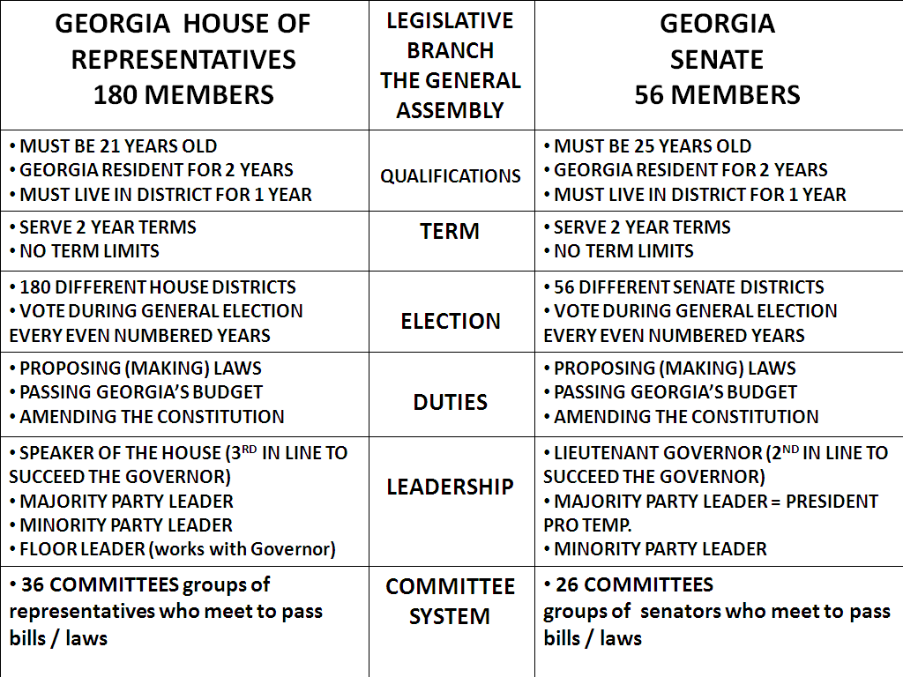 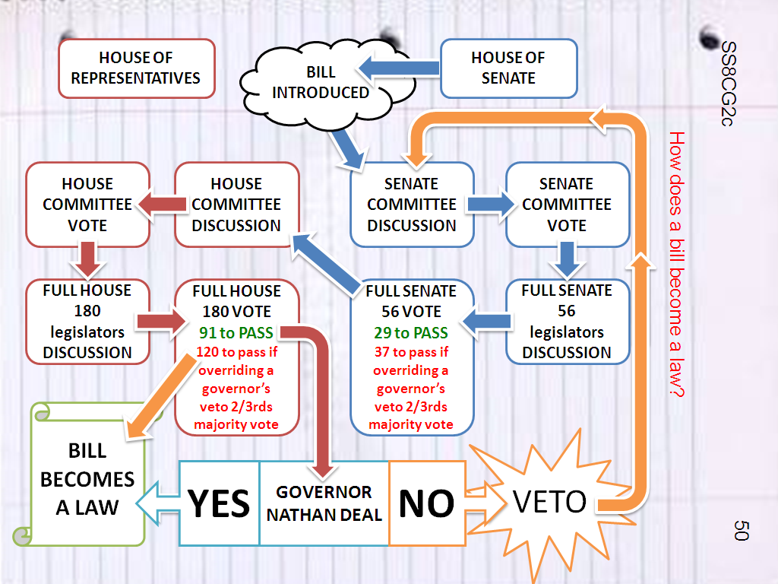

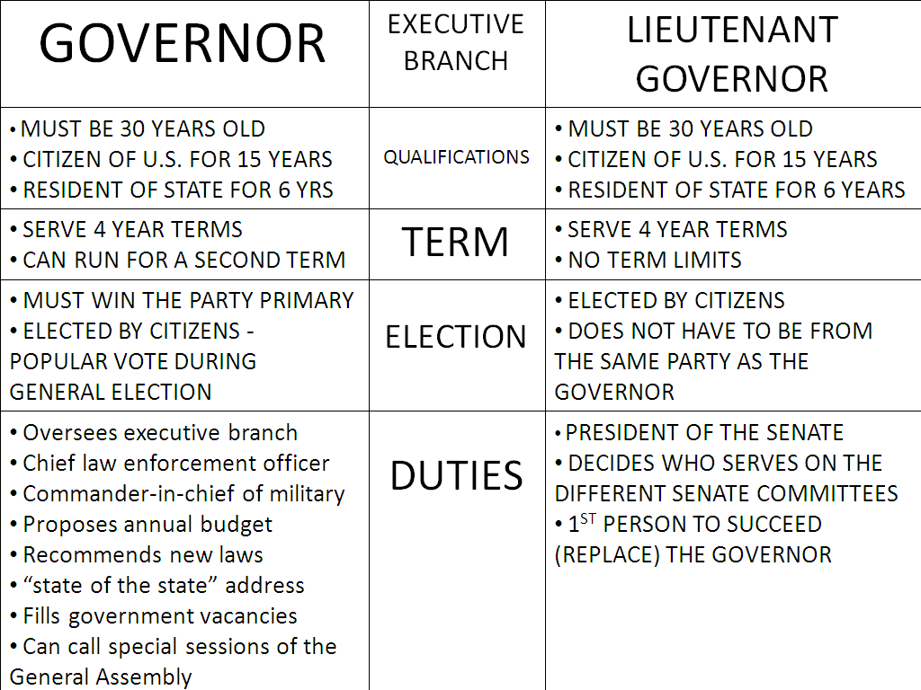 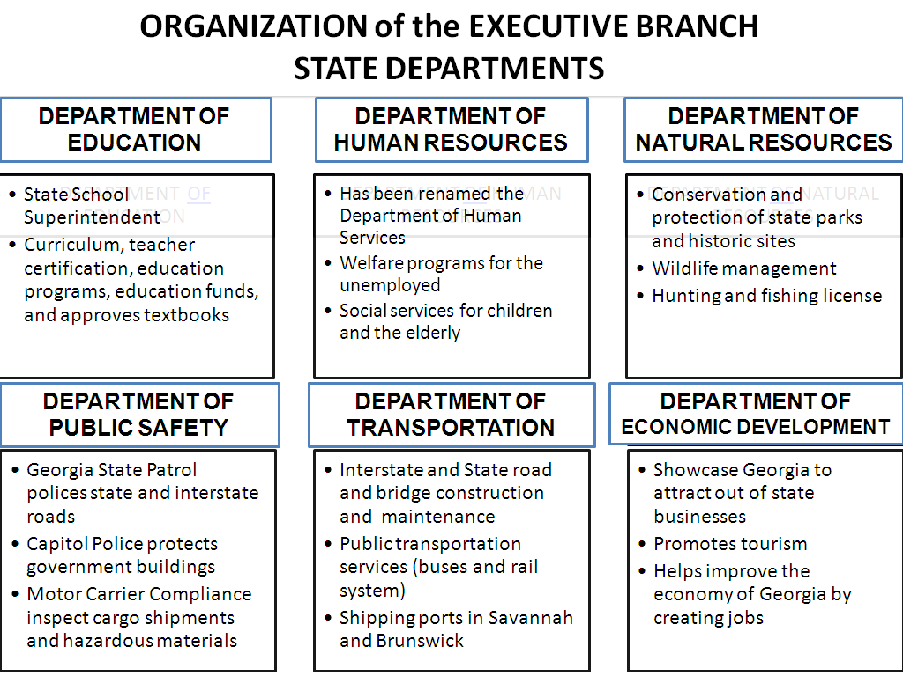

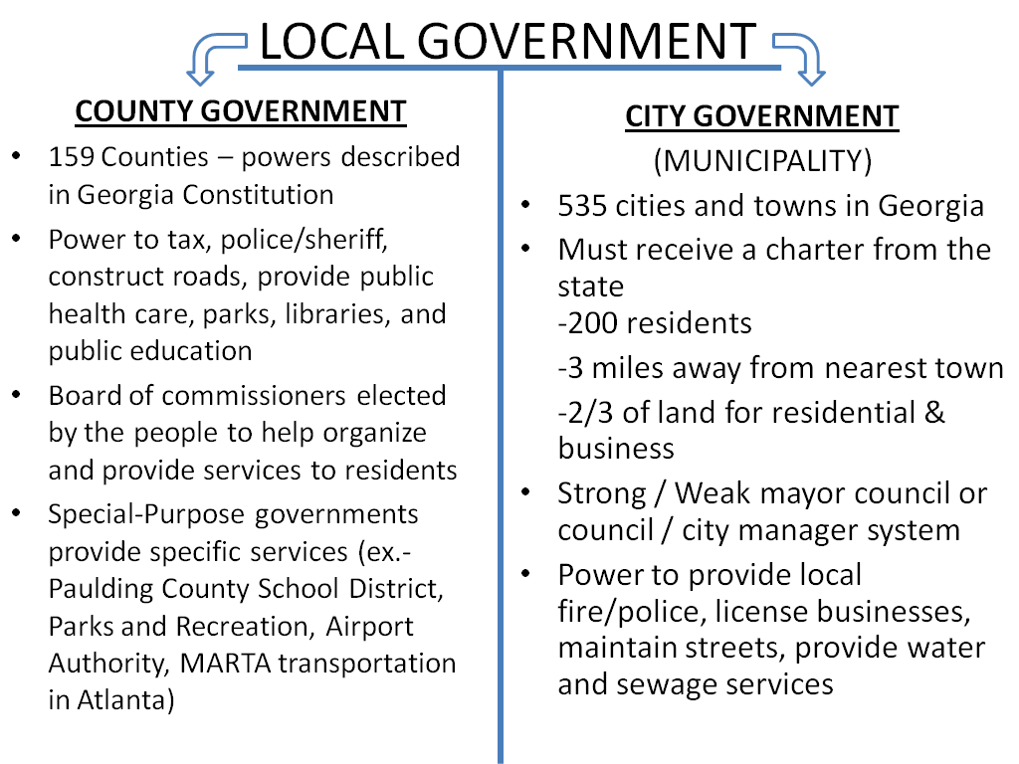 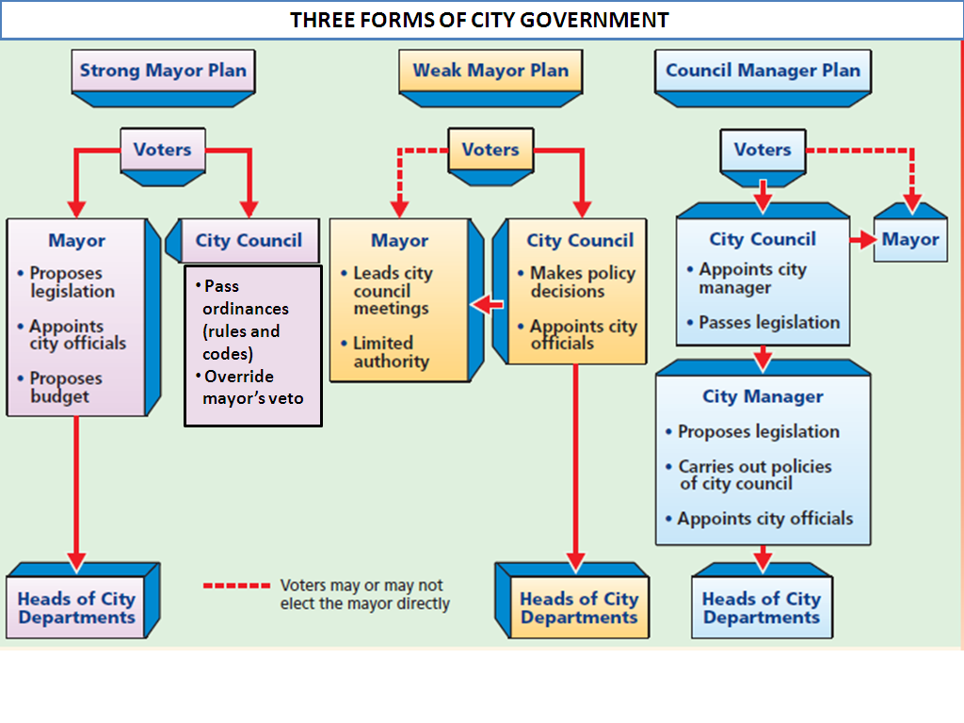

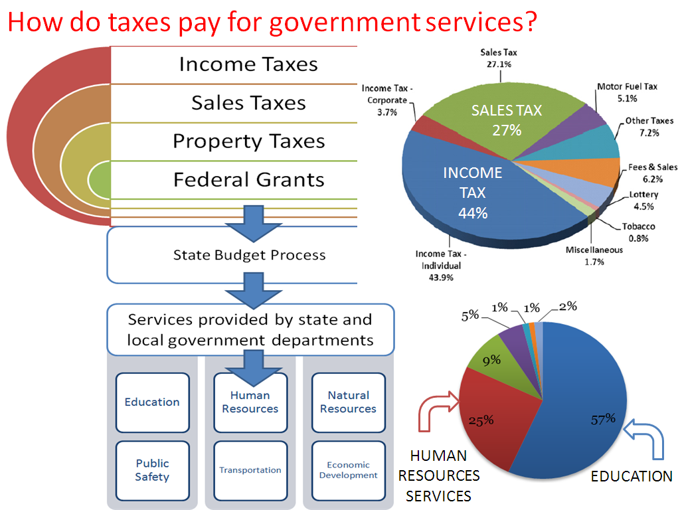 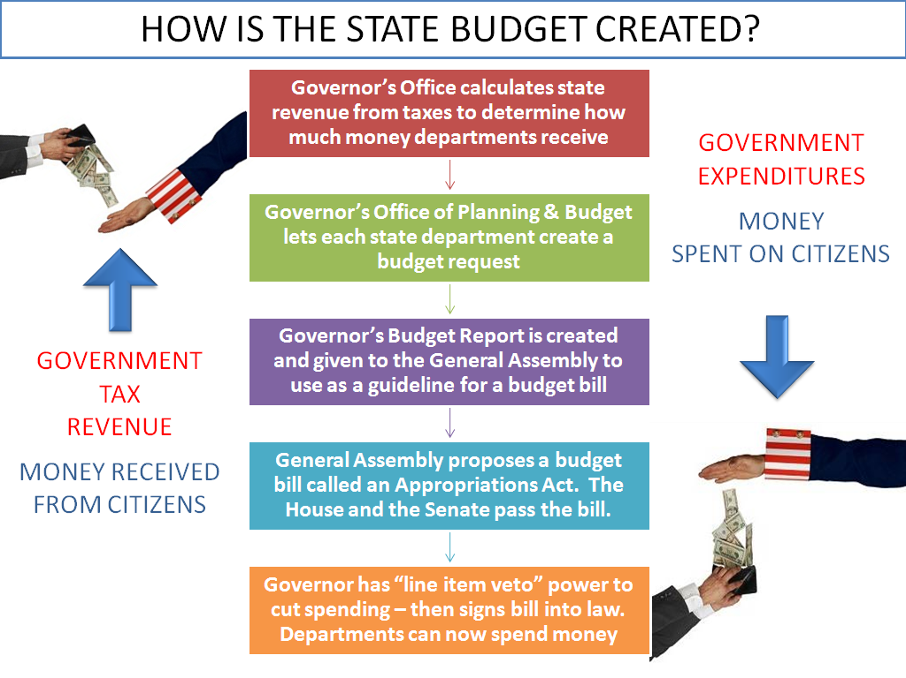

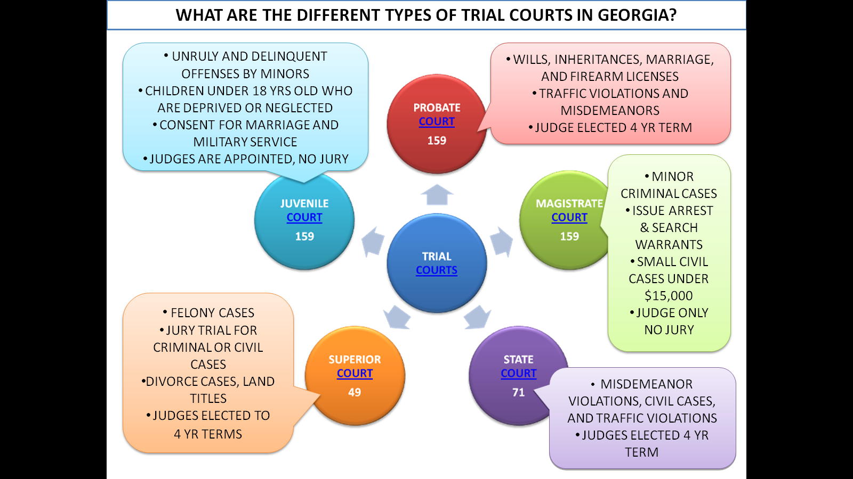 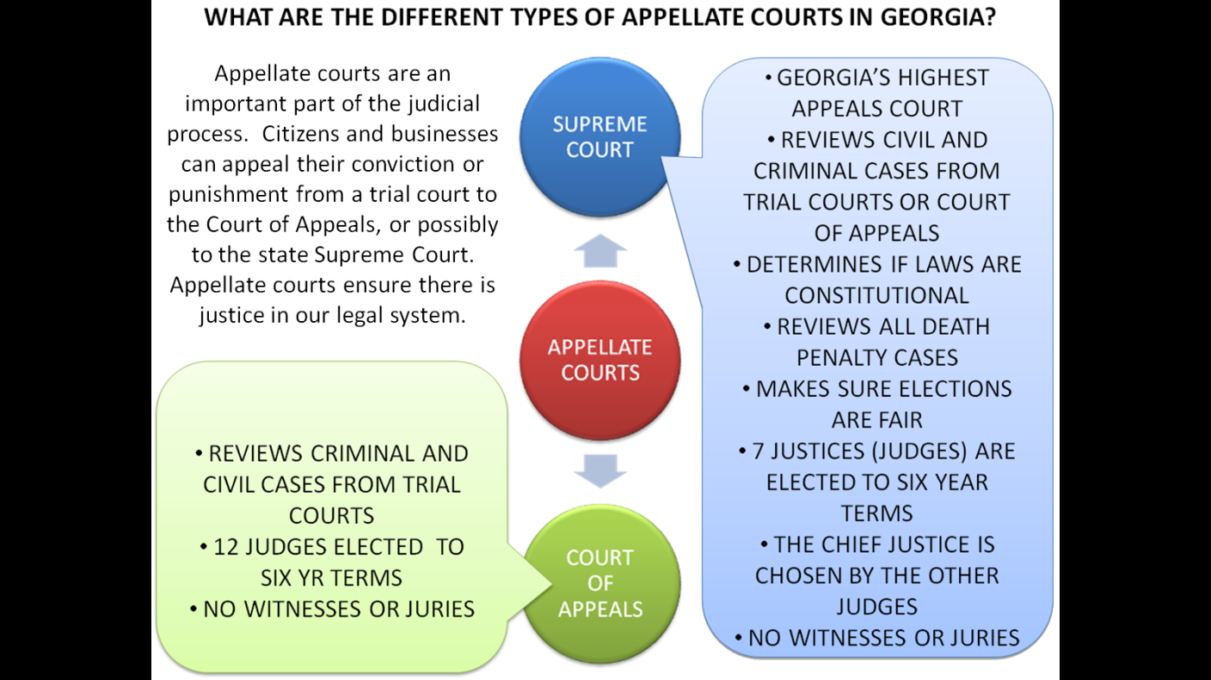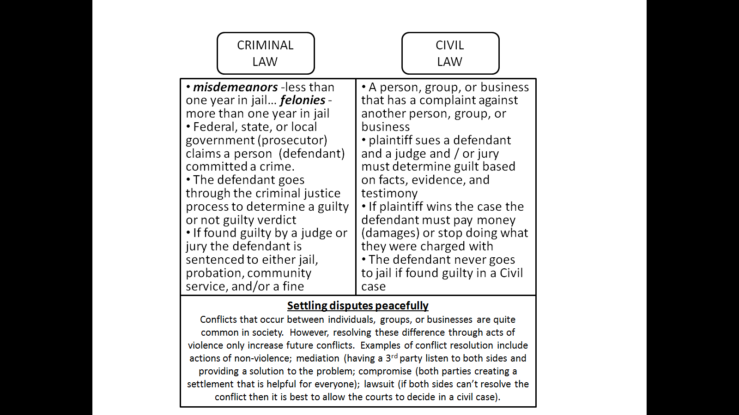

The Georgia Supreme Court is the state’s highest court and holds certain powers that no other court in Georgia has. These include interpreting laws passed by the Georgia General Assembly, resolving challenges to elections results, and reviewing cases where the death penalty was sentenced. Unlike the U.S. Supreme Court where justices are appointed by the president, the seven justices on the Georgia State Supreme Court are elected to 6 year terms by Georgia’s voters.

While all courts in the judicial branch play a part in ensuring justice in our legal system, the Supreme Court plays the most important role by interpreting laws enacted by the legislative branch. The Supreme Court accomplishes this by reviewing court cases that challenge the laws. If the Georgia Supreme Court rules that the law is unconstitutional (not supported by the Georgia or U.S. Constitution) then the law is struck down. Though the Georgia Supreme Court is the highest court in Georgia, any decision can be brought to the U.S. Supreme Court for appeal. The power to interpret laws is one of the checks that the judicial branch has over executive and legislative branches and is a way to protect against “bad” laws and ensure justice for all of Georgia’s citizens. - gadoe.org

